PROJECT PLANNING PHASE JIRA FILES

|  |  |
| --- | --- |
| Date | 28 October 2022 |
| Team ID | PNT2022TMID28207 |
| Project Name | Project – Airlines Data Analytics For Aviation Industry |
| Maximum Marks | 8 Marks |

ROADMAP:

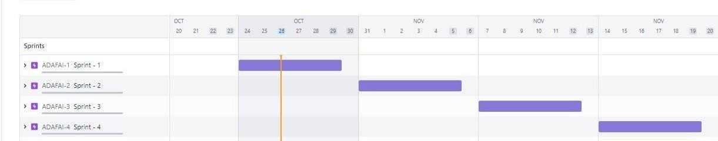

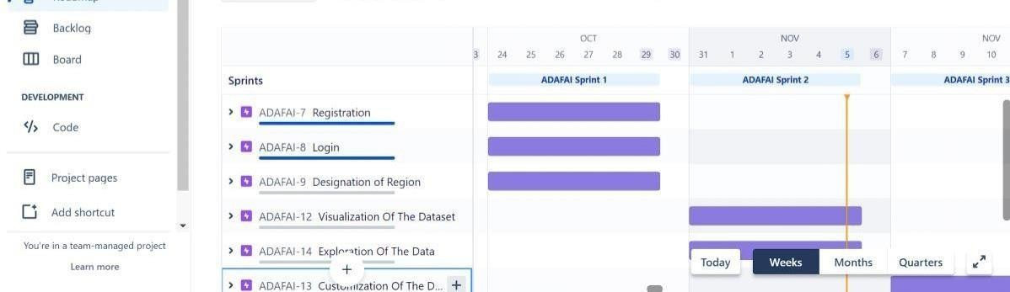

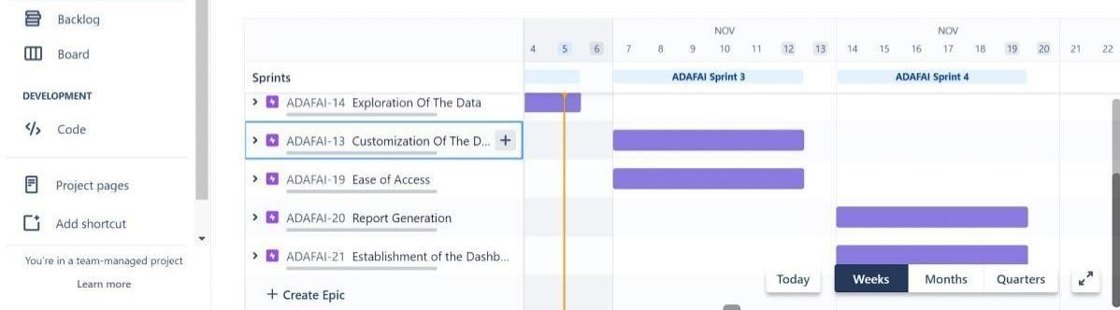

SPRINT DETAILS:

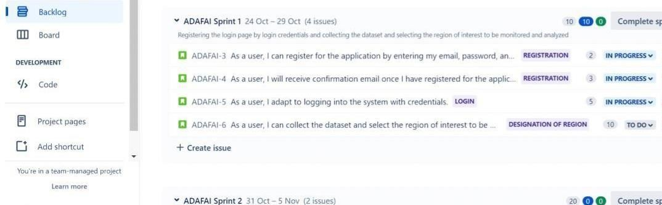

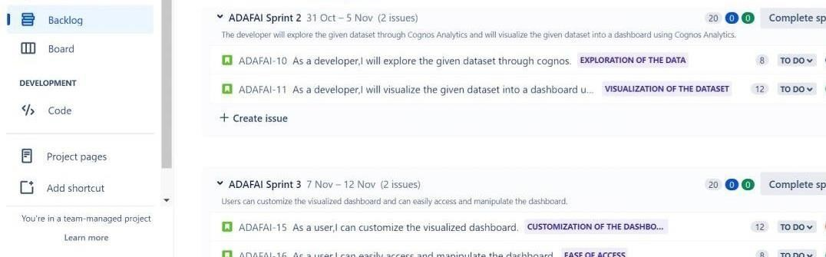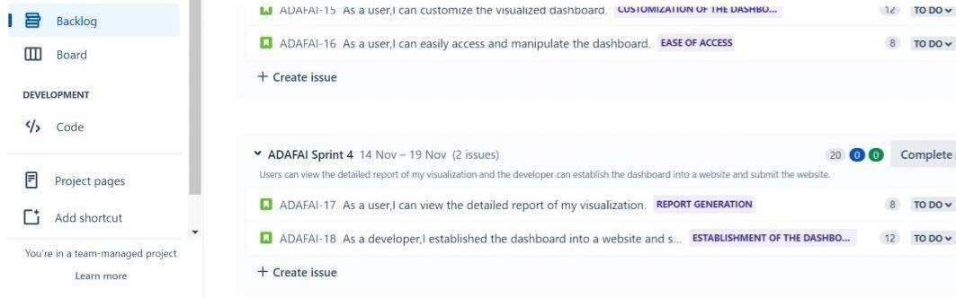

SPRINT PROGRESS:

